***COA December Social Event***

**We will be organizing a lunch from Urban Greens for all COA members that would like to order!**

**Please use the survey link below**

**to submit your order by**

**December 7th, 2021!**

[**https://www.surveymonkey.com/r/823HVQR**](https://www.surveymonkey.com/r/823HVQR)

**Happy Ordering!**

**Box Lunch Distribution**

**on**

**December 15th, 2021 @ 1130-1300**

**Primary Care Center**

**Group Room 3127-3129**

**Valley Officers will have lunch delivered from Hebrews on**

**December 14th, 2021**

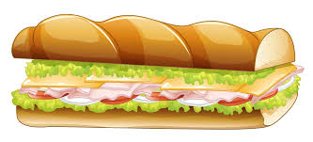[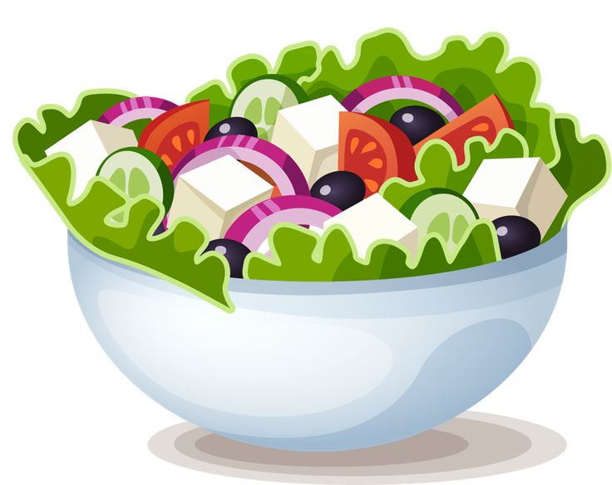](http://clipart-library.com/clipart/1524737.htm)